38.68: 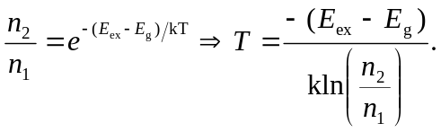
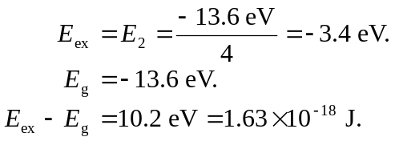
a) 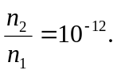
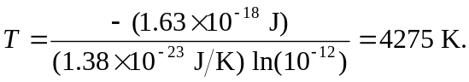
b) 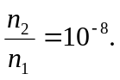
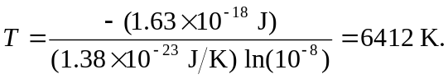
c) 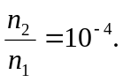
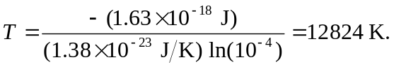
d) For absorption to take place in the Balmer series, hydrogen must 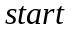 in the 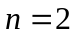 state. From part (a), colder stars have fewer atoms in this state leading to weaker absorption lines.

